FLEX

For Students and Teachers

FAST-NU

Object Oriented Analysis and Design

*Submitted By*

*Haider Wain 17L-4060*

*Basim Ahmed 17L-4022*

*Hassaan Zulqarnain 17L-4534*

*Umar Azam 17L-4506*

*Omer Asif Khan17L-4324*

*Hamza Naseem 17L-4073*

Contents

1) Project Description 2

2) Class Diagram 3

3) Use Case Diagram 3

4) Use Case Descriptions 4

i. Umar Azam 4

ii. Basim Ahmed 4

iii. Haider Wain 4

iv. Omer Asif Khan 4

v. Hassaan Zulqarnain 4

vi. Hamza Naseem 4

5) Activity Diagrams 4

i. Umar Azam 4

ii. Basim Ahmed 4

iii. Haider Wain 4

iv. Omer Asif Khan 4

v. Hassaan Zulqarnain 4

vi. Hamza Naseem 4

# Project Description

The project that our group has decided to take on is the Student and faculty portal of a university (flexstudent.nu.edu.pk & flex.nu.edu.pk as a reference). The purpose of this project is to have information of all the students and teachers in one place and make it easily accessible for those that may need it.

There are two main users of this system. A student studying in the university or a teacher that is teaching at the university. Both types of users have common functions and attributes such as logging in and signing out, changing password and viewing their personal details (ID#, name, email, contact information, CNIC etc.)

**Student side:** There are two types of students, one is an undergraduate student and the other is a graduate student. Each student has a unique id given to them which is what they will use to login into the system. Every student can make up their own password and change it whenever they want. Basic information about each student is saved such as name, roll number, email, contact information, CNIC and address. Each student has the ability to login and check their marks and attendance they are enrolled in. they can also see their current GPA and a print a complete transcript of all their grades. Students have the ability to see what courses they can enroll in, enroll in a course and drop a course they are currently enrolled in. each student can view the list of courses they are studying for the semester, check their attendance and also check the marks they have in each course. Every student can also print their fee challan to pay their dues.

**Faculty side:** There are two types of faculty members, visiting faculty and permanent faculty. Each faculty member has their own login and password and can use it to access the system. Faculty members have basic information like the students but have functionality different from the students. Teachers can login to check/update their student’s attendance. They can edit/update narks of the students and add or remove students from their course. A teacher is not bound to a single course and can teach multiple courses and only a permanent faculty member is allowed to have an assistant (TA).

# Class Diagram

Following is our high-level class diagram. We have made an assumption:

1. One Teacher can only have one TA for multiple courses.

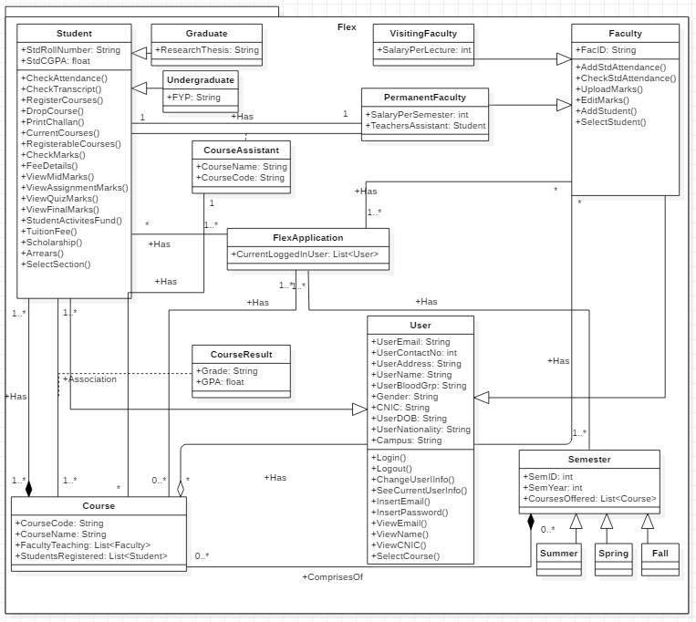

# Use Case Diagram

Following is our use case diagram for Flex.

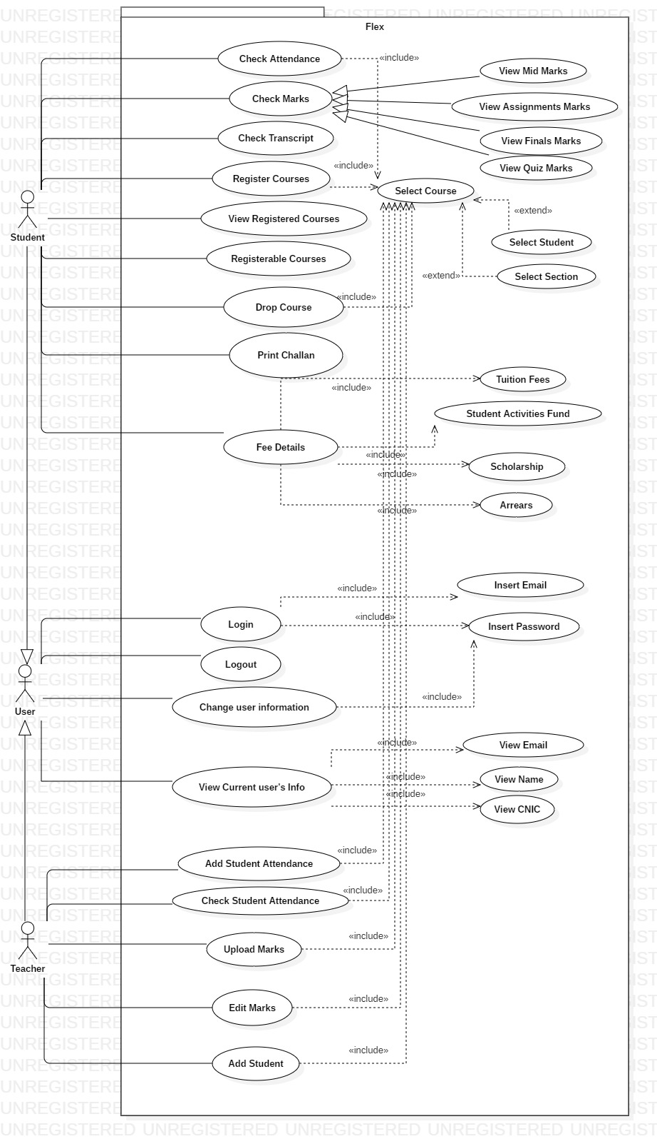

# Use Case Descriptions

Following is the use case descriptions per group member:

# Umar Azam

1. **Use Case:** Check Attendance (Student)

**Summary:** Flex offers functionality to the student, of checking his/her attendance.

**Actors:** Student

**Preconditions:** Student is logged in and making a decision of which functionality he wants to use. By default, he is at homepage.

**Description:** The application displays the button of Check Attendance for student and when clicked upon, opens up a page with list of registered courses from which he selects a single course. Upon selection, a table is shown on which the attendance of the student in the course is shown.

**Exceptions:**

*Failed to load the page:* In case of failure, application will display the message “Please try again by clicking the refresh button.”

**Postconditions:** The application waits for the next functionality to be requested by the user.

1. **Use Case:** Upload Marks (Teacher)

**Summary:** Teacher can upload the marks of student(s) registered in the courses he is teaching.

**Actors:** Teacher

**Preconditions:** Teacher is logged in and is making a decision of which functionality he wants to use. By default, he is at homepage.

**Description:** The application displays the button of Upload Marks for Teacher and when clicked upon, opens up a page with a list of courses that teacher is teaching. Teacher selects a course which then opens up a page with a list of students he is teaching in that course. He then selects the student of whom he wants to upload the marks, another page opens and he enters the marks.

**Exceptions:**

*Failed to load the page:* In case of failure, application will display the message “Please try again by clicking the refresh button.”

**Postconditions:** After the teacher has uploaded the marks, he is then returned to the page containing the list of students in the course he selected previously.

1. **Use Case:** Edit Marks (Teacher)

**Summary:** Teacher can upload the marks of student(s) registered in the courses he is teaching.

**Actors:** Teacher

**Preconditions:** Teacher is logged in and is making a decision of which functionality he wants to use. By default, he is at homepage.

**Description:** The application displays the button of Edit Marks for Teacher and when clicked upon, opens up a page with a list of courses that teacher is teaching. Teacher selects a course which then opens up a page with a list of students he is teaching in that course. He then selects the student of whom he wants to edit the marks, another page opens and he edits the marks.

**Postconditions:** After the teacher has edited the marks, he is then returned to the page containing the list of students in the course he selected previously.

* **Haider Wain:**

1. **Use Case:** Login

**Summary:** A user can log in the website from his/her account to view related information.

A**ctors:**  User (Student OR Teacher)

**Preconditions:** The user should be on <http://flexstudent.nu.edu.pk/Login> page and provide correct credentials.

**Description:** User can enter his/her rollNumber/TeacherID and password that he set for his account, to log in to his/her account. Then he/she can view information that is related to his/her account like viewing his/her marks, registering courses etc. All the functionalities require you to log in to your account.

**Exceptions:** Entering the wrong username + password combination will refresh the page and the website will ask you to enter your credentials again.

**Postconditions:** After the user has entered correct credentials, he/she will be redirected to the homepage of flex.

1. **User Case:** Logout

**Summary:** User can log out of his/her account after he/she is done with the session.

**Actors:** User (Student OR Teacher)

**Preconditions:** The user should be logged in.

**Summary:** User can see and click the button of logout on top right of the website. By clicking the button, the user will be redirected to <http://flexstudent.nu.edu.pk/Login>. If a user is Idle/Away from keyboard for more than 10 minutes, he/sure will also be forced to logout, in order to secure his/her account if they forget to log it out in public computers.

**Exceptions:** Failed to load the page: In case of failure, application will display the message “Please try again by clicking the refresh button.

**Postconditions:** After logging out of the account, the user will be redirected to the page <http://flexstudent.nu.edu.pk/Login>.

1. **User Case:** Change Current User’s Information

**Summary:** User can change his/her account details (Phone, email, contact, address etc).

**Actors:** User (Student OR Teacher)

**Preconditions:** The user should be logged in.

**Summary:** User can go to his/her profile and click on “Account details” button there and change his details if necessary. The user will be allowed to change his/her phone number, email, address, password etc. Further verification will be asked by asking the user to enter his/her password before changing any details.

**Exceptions:** Failed to load the page: In case of failure, application will display the message “Please try again by clicking the refresh button.

**Postconditions:** If password is changed, user will be logged out and asked to log in again with the new password. If other details are changed, he/she will be redirected to homepage.

# Omer Asif Khan

# Hassaan Zulqarnain

# Hamza Naseem

# Activity Diagrams

Following are our activity diagrams per group member.

# Umar Azam

# Basim Ahmed

# Haider Wain

# Omer Asif Khan

# Hassaan Zulqarnain

# Hamza Naseem